Online Plasma Donation System (Android)
Design Document

Version 1.1



Group ID: F2102DD087 (BC180406444)
Supervisor Name : Waqas Ahmad

Revision History

Date (dd/mm/yyyy) | Version | Description | Author
4/3/2022 | 1.1 | In this document, we have included ERD, Sequence and Class Diagram Database and Interface Design, and Test Cases. Design documents describe the system requirements, system and subsystem architecture, processing logic and external interface. The main purpose of this is to formally document the design of software. | F2102DD087 (BC180406444)

Table of Contents

- Introduction of Design Document………………………...(4)
- Entity Relationship Diagram (ERD)…………………........(5)
- Sequence Diagrams…………………………......................(5)
- Architecture Design Diagram..............................................(10)
- Class Diagram ………………………………………………….(11)
- Database Design………………………………………………..(11)
- Interface Design………………………………………………..(12)
- Test Cases………………………………………………………(13)

- Introduction of Design Document
The Software Design Document is a document to provide documentation which will be used later in software development by providing the details for how the software should be built. Within the Software Design Document are narrative and graphical documentation of the software design for the project including Entity Relationship Diagram (ERD), Sequence Diagrams, Architecture Design Diagram, and Class diagram, Database Design, Interface Design and Test Cases.

Benefits:

There are many benefits of a well-defined design document some of those are:
User’s expectation of the system is documented properly and helps a lot later while developing the site. All major design issues are discussed. Different analysis on the system can be performed. It saves a lot of time of the developer when all the functionality of the system is captured properly and is documented in a file.

Purpose:

The purpose of the Software Design Document is to provide a description of the design of a system fully enough to allow for software development to proceed with an understanding of what is to be built and how it is expected to build. The Software Design Document provides information necessary to provide description of the details for the software and system to be built.

- Entity Relationship Diagram (ERD)
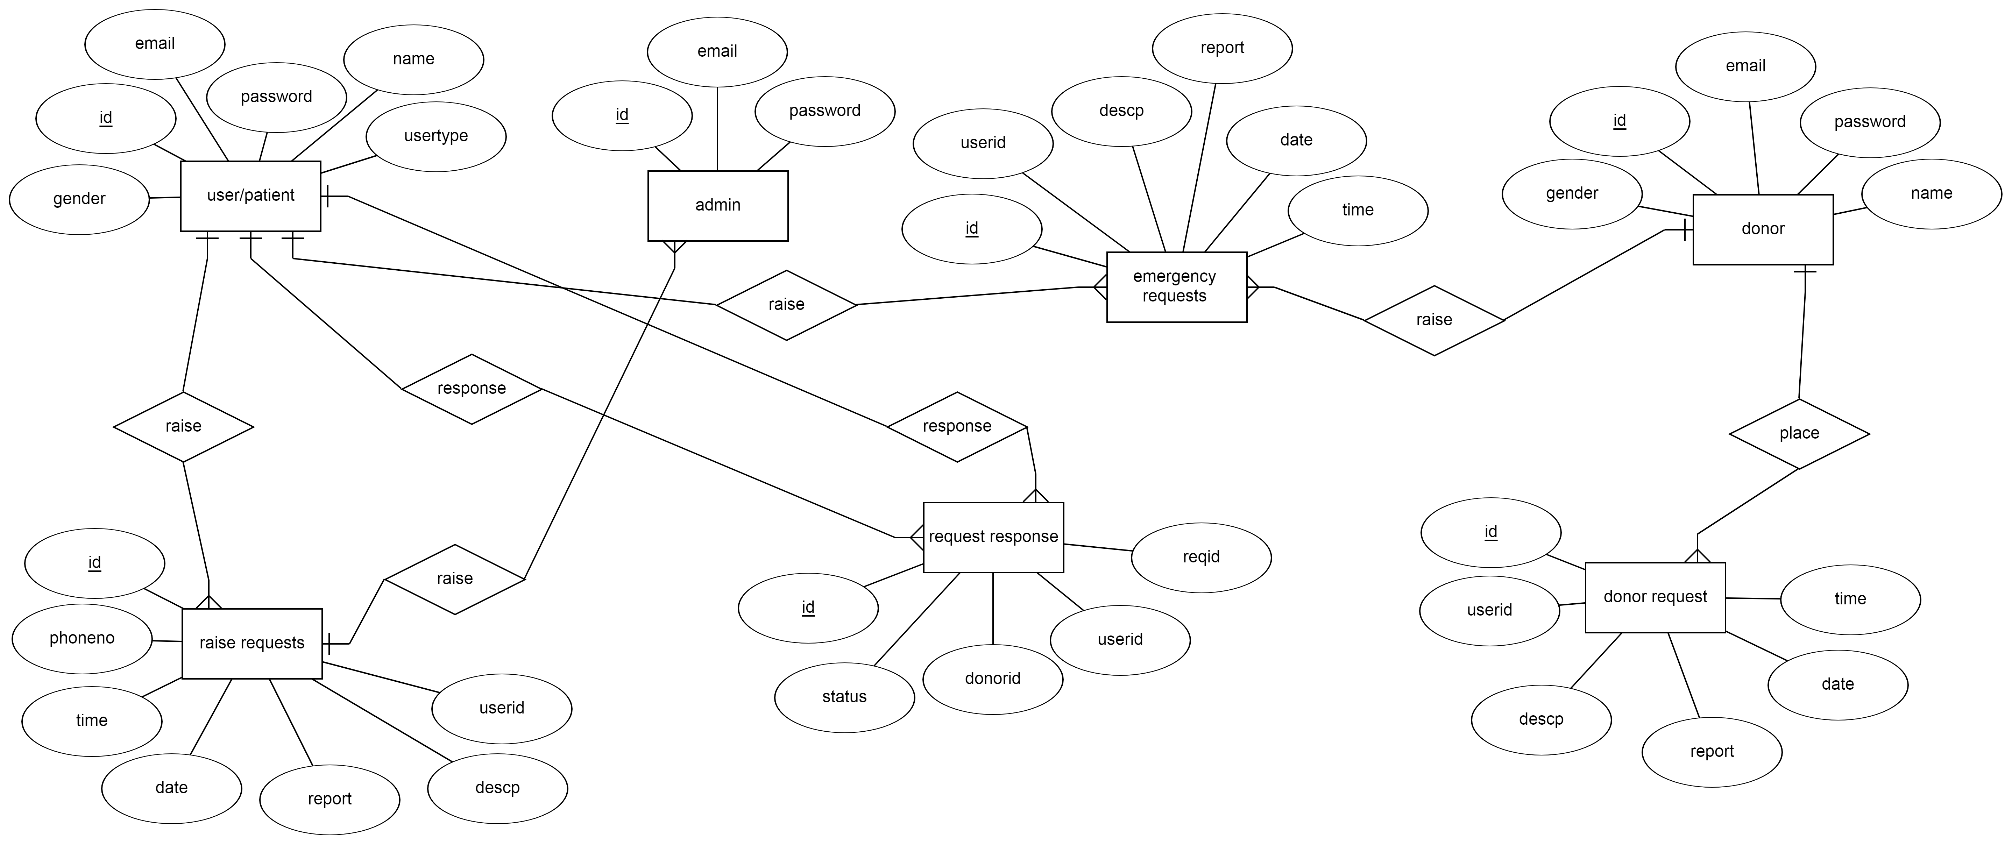
- Sequence Diagrams
1. register
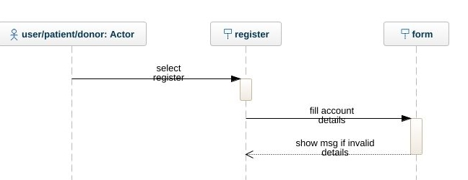

2. login
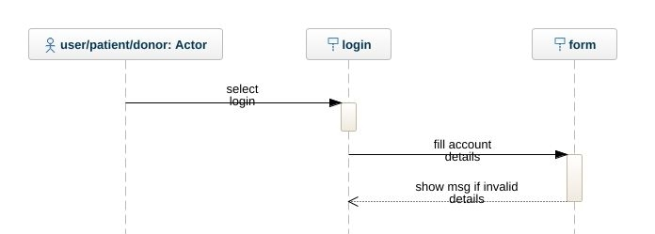

3.raise request
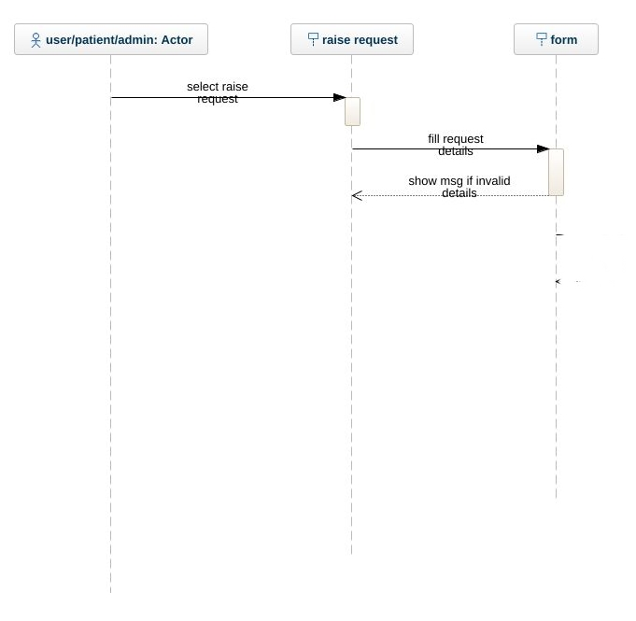

4. upload report
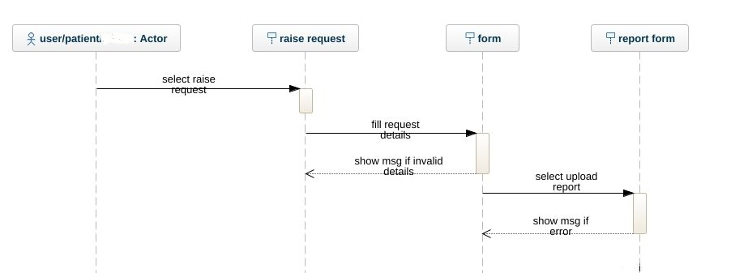
5. emergency request
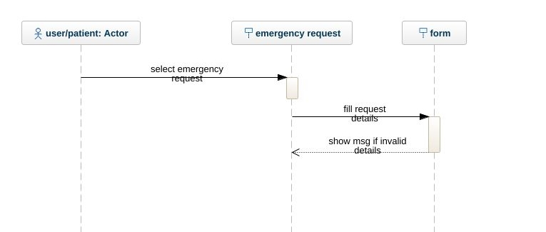

6. Request response
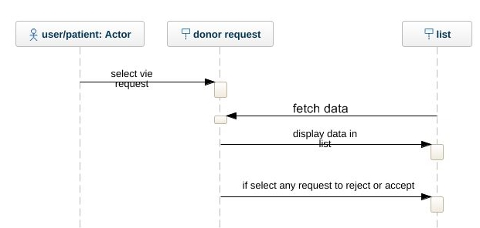

7. Donate request
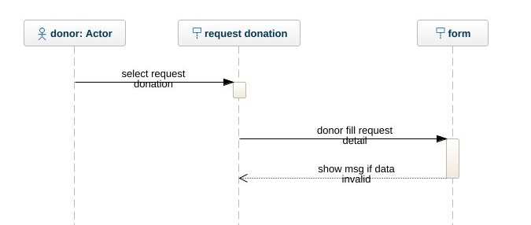

8. View request history
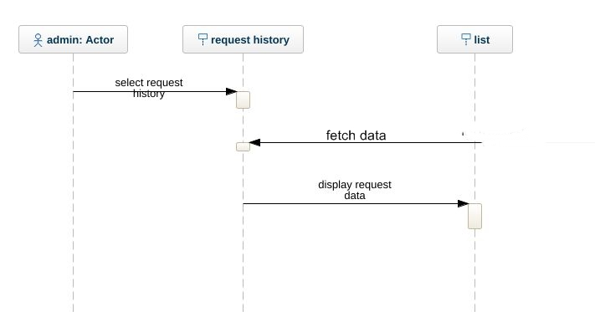
9. view profiles
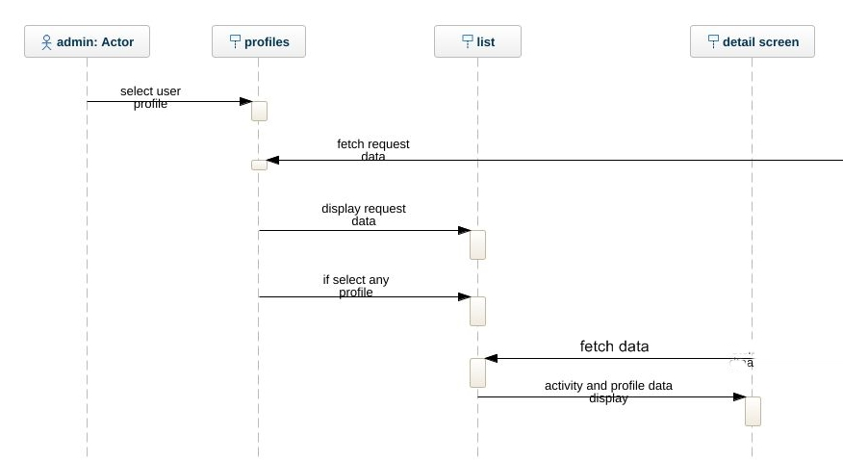

10. block user
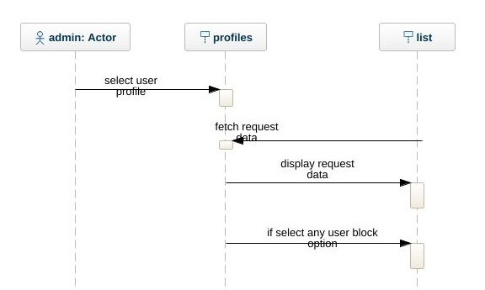
- Architecture Design Diagram
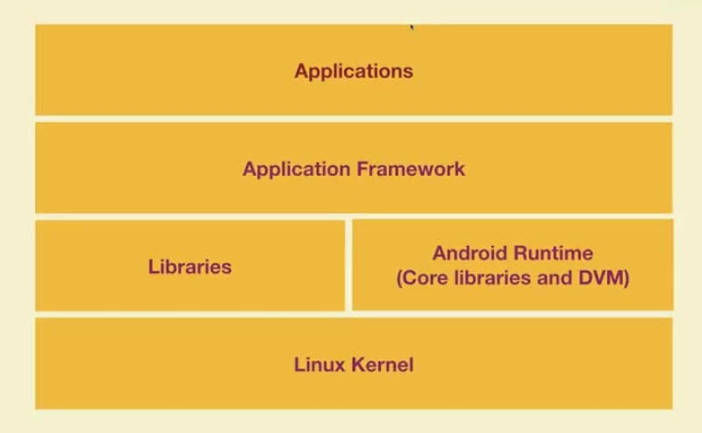
- Class Diagram

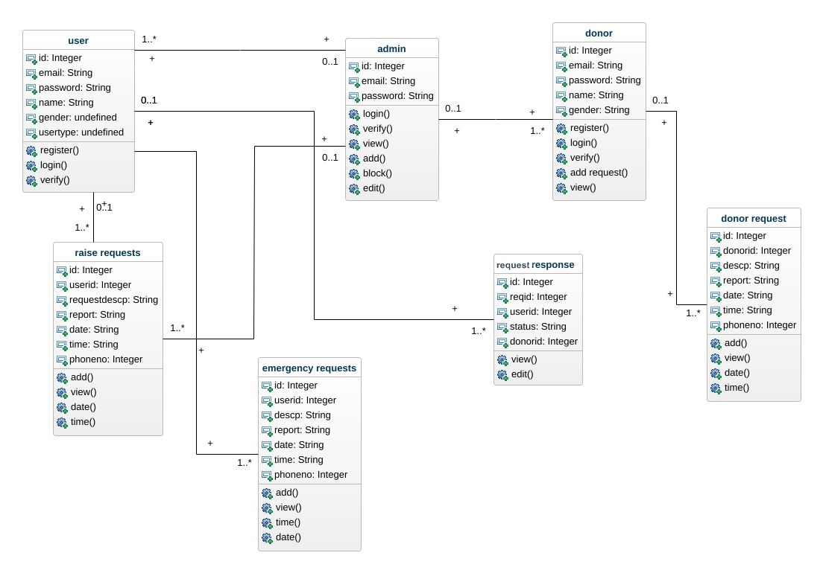

- Database Design

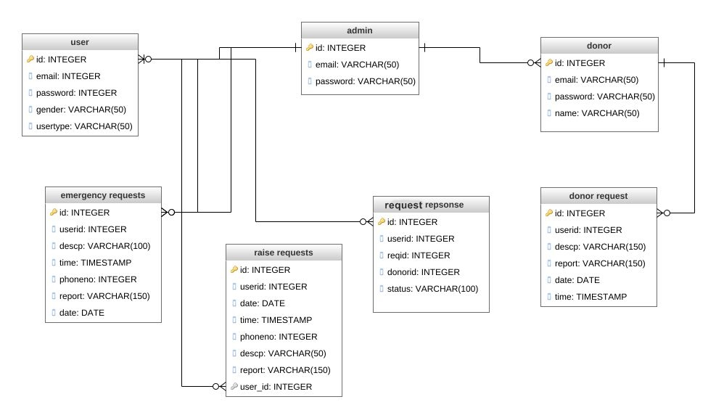

- Interface Design

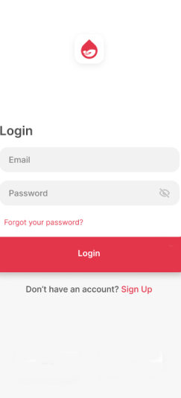

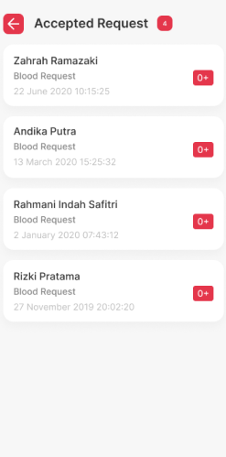

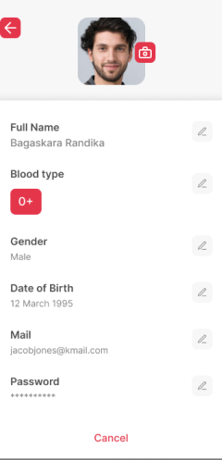

- Test Cases

Test Case # 1

Test Case Title: register

Preconditions | User open the app
Actions | User select register button to register himself in the app
Expected Results | System successfully register the user and show user detail in the database
Tested By: | F2102DD087 (BC180406444)
Result | Pass/Fail

Test Case # 2

Test Case Title: login

Preconditions | Users register himself in the app
Actions | User can login in his account by selecting login button
Expected Results | System successfully login the user in his account
Tested By: | F2102DD087 (BC180406444)
Result | Pass/Fail

Test Case # 3

Test Case Title: raise request

Preconditions | User login in his account
Actions | User select raise request option and fill request detail and submit request
Expected Results | System successfully save the raise request data in the database and notify request submit successfully
Tested By: | F2102DD087 (BC180406444)
Result | Pass/Fail

Test Case # 4

Test Case Title: upload report

Preconditions | User login in his account
Actions | User raise the request and upload the report for the request
Expected Results | System successfully save the upload report in the database and notify uploaded successfully
Tested By: | F2102DD087 (BC180406444)
Result | Pass/Fail

Test Case # 5

Test Case Title: emergency request

Preconditions | User login in his account
Actions | User select emergency request option and fill request detail and submit request
Expected Results | System successfully save the raise request data in the database and notify request submit successfully
Tested By: | F2102DD087 (BC180406444)
Result | Pass/Fail

Test Case # 6

Test Case Title: request response

Preconditions | User login in his account
Actions | User select the donor request option and can accept or reject the request by selecting their option
Expected Results | System successfully save the response of the request data in the database and notify response submit successfully
Tested By: | F2102DD087 (BC180406444)
Result | Pass/Fail

Test Case # 7

Test Case Title: donor request donating

Preconditions | Donor login in his account
Actions | Donor select donate request option and fill request detail and submit request
Expected Results | System successfully save the donate request data in the database and notify request submit successfully
Tested By: | F2102DD087 (BC180406444)
Result | Pass/Fail

Test Case # 8

Test Case Title: view request history

Preconditions | user login in his account
Actions | User select view request option to view all request
Expected Results | System successfully shows the request data from the database
Tested By: | F2102DD087 (BC180406444)
Result | Pass/Fail

Test Case # 9

Test Case Title: view profile

Preconditions | Admin login in his account
Actions | admin select view profile option to view all users detail
Expected Results | System successfully shows the profile data from the database
Tested By: | F2102DD087 (BC180406444)
Result | Pass/Fail

Test Case # 10

Test Case Title: block user

Preconditions | Admin login in his account
Actions | admin select view profile option and select any user to block it by selecting delete option
Expected Results | System successfully block the user from the app.
Tested By: | F2102DD087 (BC180406444)
Result | Pass/Fail

